Software Requirements Specification

For

Agile-PDS

Version 0.5 draft

Prepared by Saurav Singh

Ronak Jain

Shiv Bajpai

Raaghav Mehta

Siddhant Misra

16-September-2016

Table of Contents

Table of Contents ii

Revision History ii

1. Introduction 3

1.1 Purpose 3

1.2 Document Conventions 3

1.3 Intended Audience and Reading Suggestions 3

1.4 Product Scope 3

1.5 References 4

2. Overall Description 4

2.1 Product Perspective 4

2.2 Product Functions 4

2.3 User Classes and Characteristics 4

2.4 Operating Environment 6

2.5 Design and Implementation Constraints 6

2.6 User Documentation 6

2.7 Assumptions and Dependencies 6

3. External Interface Requirements 7

3.1 User Interfaces 7

3.2 Hardware Interfaces 7

3.3 Software Interfaces 7

3.4 Communications Interfaces 7

4. System Features 8

4.1 Creating a Task 8

4.2 Modify,View,Delete Task 8

4.3 Creating a Module 8

4.4 Modify,View,Delete Module 9

4.5 Assigning the module to PDT 9

5. Other Nonfunctional Requirements 9

5.1 Performance Requirements 9

5.2 Safety Requirements 10

5.3 Security Requirements 10

5.4 Software Quality Attributes 10

5.5 Business Rules 10

Appendix A: Glossary 10

Revision History

|  |  |  |  |
| --- | --- | --- | --- |
| **Name** | **Date** | **Reason For Changes** | **Version** |
| Saurav Singh & Ronak Jain. | 14-08-16 | Initial Draft | 0.5 Draft |
|  |  |  |  |

**1. Introduction**

**1.1 Purpose**

Agile Development System is basically an open software which will help in designing of the product and mainly software development presented to all the sectors of our society. Agile entails the assessment of the project all throughout the product development life-cycle. In this SRS document we will be covering all the important changes that are done in our software and will fulfil the following important features of agile like Iterativeness, controls the rhythm of work, incremental technique, designed to reduce cost and time to the market, responsiveness of product development teams, helps in dividing the work into hierarchies of a particular organization into specific modules.

The main purpose of this agile based PDS is to make easier the communication and interaction between employees, managers and customers.

This document will attempt to provide with all the basic needs for the development of a product with the help of agile.

**1.2 Document Conventions**

This document is based on IEEE standard with the font ‘ARIAL’ and heading size of 20, subheading size of 14 and content of size 12.

**1.3 Intended audience and reading suggestions**

This document is particularly intended for all the sectors like - IT, film industry, business management, software development companies, Board of directors, Managers, department hierarchies for maintaining the product’s development at different phases.

**1.4 Product scope**

Agile product development, nowadays is increasing its popularity and it not only stick towards the software development. Times are changing and we are seeing more and more applications of agile in broader product development in sales and marketing departments. This change will help more and more industries of any genre to use this product and will facilitate better understanding of development to their customers and even their employees.

Basically if one software development company is in involvement with this tool then it can help that particular firm to manage the development of a particular software by dividing the work in modules and giving that particular work to all the different departments present in the company’s organizational structure. Manager of that particular firm can have a full time check over his employees that in how much time and individual group is completing the assigned task and what are the changes getting made during that interval of time frame.

By this it will increase the communication and interaction among the different layers easily and will help in better understanding.

Some of the major changes in this technology are:

1. Collaboration and interaction over rigid rules and lines of authority.
2. Involvement of customers and other stakeholders in the development process.
3. Prototypes are given more importance than the documentation.
4. Ability to respond to change.

**1.5 References**

IEEE. *IEEE Std 830-1998 IEEE Recommended Practice for Software Requirements*

*Specifications.* IEEE Computer Society, 1998.

**2. Overall Description**

**2.1 Product Perspective.**

The Agile based Product Development Software (Agile-PDS) is a unique system which will divide things in organizational hierarchy, and helps in forming the development timeline required for the completion of the product. The use case diagram in Figure 1 illustrates the external entities and system interfaces for release 1.0.The system is expected to evolve over several releases, ultimately connecting the customer and the firm to have a strong communication with each other leading towards a successful product, and to learn more about the phases of the product (i.e. Design, implementation, product modelling and testing).

**2.2 Product Functions.**

Agile-PDS is responsible for the organizational hierarchy made for the development phase of the final product.The firm’s manager is responsible for creating the task,defining modules(goals) of the product and assigning the modules towards its product development team.Agile-PDS provides a user-interface to the firm’s manager and its customer to see the production timeline of the final product.It also provides an interface to the employees working under the product development team to input the further work progress of the modules.The customer can see the changes made to its product lively and can suggest any changes to be made through Agile-PDS chat-system/commenting,the respective changes would be made by the respective employee working under that module and it would be later reflected on the customer’s interface.The use case diagram in Figure 1 depicts the major groups of related requirements and how they work out in a particular scenario.

**2.3 User Cases and Characteristics.**

Customer A customer is the actor who is defining the product specification to the

Manager/HRD,which in turn is defining modules for the

product.Customer is also responsible for changes in modules and is

the only one in the system who is defining final objectives.Customer

has a given interface in which he first logs in through his credentials

and then would be able to see the product’s timeline, and if he wants to

implements some changes accordingly he can communicate with the

respective through the system’s chat/commenting service.

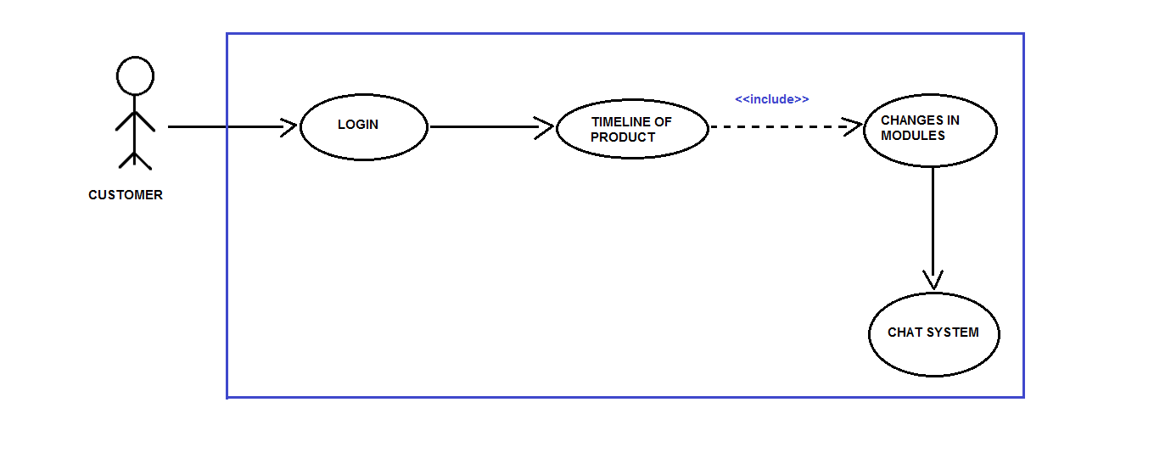

Figure 1.1

Manager/HRD

Manager/HRD is the actor who is responsible for the commencement

of the product development phase, which he does through the system’s

interface provided to him.Manager/HRD first login’s with its credentials

then can either view the earlier created tasks or creates a new

one.Manager/HRD then defines the module's(objectives) according to

the customer’s requirements of the product.Manager/HRD is also

responsible for the assignment of the modules to their respective

product development team(PDT).

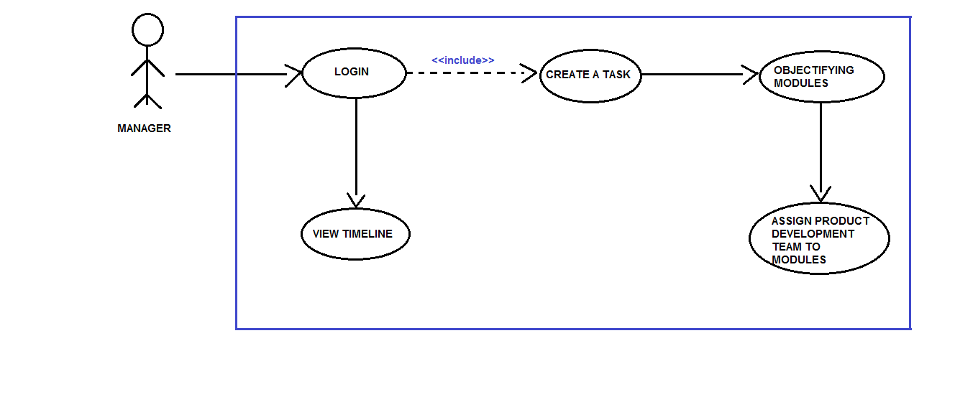

Figure 1.2

Employee The employee working in the PDT is the actor who is responsible for

the daily reporting on his assigned module by the

Manager/HRD. Employee is also responsible for the changes done to

the modules according to the customer. An employee can get its

objectives much clearer by communicating directly through the

Customer by Chat/Commenting service of the system.

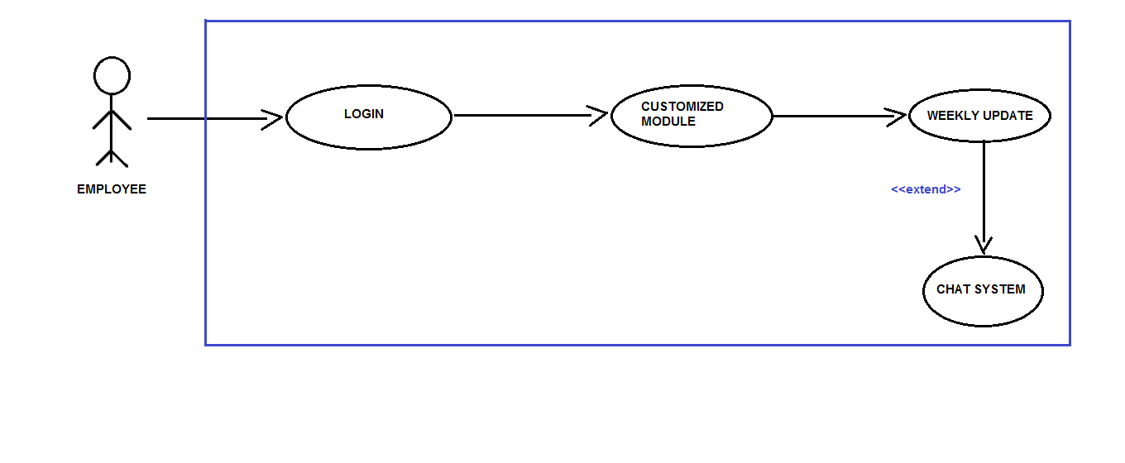

Figure 1.3

**2.4 Operating Environment.**

OE-1: The Agile-PDS shall operate with the following web browsers:

Microsoft Edge version-38 or latest, Google Chrome Version-53 or

Latest.

OE-2 The Agile-PDS shall operate on a server running the current corporate

approved versions of Jboss and Wildfly Web Server.

OE-3 The Agile-PDS shall permit employee access from the firm’s intranet,

and if the employee is allowed for the outside access through the firm’s

firewall,from an internet connection at employees remote location.

OE-4 The Agile-PDS shall have a hosted interface on the internet for the

customer.

**2.5 Design and Implementation Constraints.**

CON-1 The system shall use the current corporate standard of Mysql engine InnoDB.

CON-2 The system shall use the current corporate standard of Nosql with MongoDB.

CON-3 All HTML code shall conform to HTML 5.0 standard.

CON-4 All scripts shall be written in JavaScripts.

CON-5 The system’s design,code and maintenance shall follow the Eclipse Neon Java EE tools.

**2.6 User Documentation.**

UD-1 The system shall provide an online hierarchical and cross-linked help

system in HTML that describes and illustrates all system functions.

UD-2 The first time customer when accesses the system, on demand it will

be given Information regarding the User Interfaces.

**2.7 Assumptions and Dependencies.**

AS1 The final product made by the firm is feasible according to their

standards.

DE1 The operation of Agile-PDS depends on the firm’s Manager/HRD who

is responsible for the creation of the task and defining its modules,later

assigning it to the product development team.

DE2 The operation of Agile-PDS depends on the employees working in

product development team inputting their work progress which helps in framing the timeline of the final product.

DE3 The operation of Agile-PDS depends on the customer in regular

commentation and communication about the final product’s

modules/goals.

**3. External Interface Requirements**

**3.1 User Interfaces:**

UI 1: The XYZ screen will display a login page with a dropbox, where there can be three different types of personnels entering their respective **username and password**. After entering their credentials, there can be be three different pages for Customers, Development Team and Employees, this will be facilitated with the help of the dropbox.

UI(for Customers): The customers can see the progress and the timeline for the respective project. Also there will be a **chat system,** if there are any messages for any of the teams, the same can be conveyed through the chat system.

UI(for manager):  The manager/HRD can create a new project, set the modules, assign teams to these modules and specify the timeline within which all this work is supposed to be done.

UI(for Development team): The personnel in the Development team can update their project progress/report, time to time. They can also send and revert messages through the **chat system**, if needed.

**3.2 Hardware Interfaces.**

No hardware interfaces have been identified.

**3.3 Software Interfaces.**

SI1 Chat System/Commenting Service.

SI1.1 Chat System is responsible for sending the comments provided by the

Customer to its designated employee working on that particular

module.

SI1.2 Chat System can also be utilized by the employee in clearing its

objectives while designing/implementing its module.

**3.4 Communication Interfaces.**

CI-1 The Agile-PDS should send an email to the customer on creation of the

task and about its modules.

CI-2 The Agile-PDS should send an email to the customer to report any

problems with the modules(objectifying goals).

**4. System Features**

**4.1 Creating a Task**

**4.1.1 Description and Priority**

Agile PDS whose identity has been verified and is right now one of the most      stable platform for the development of any product or software. Its main purpose is to ease and fasten the communication link between the manager and employees, employees and customers.Priority = High.

**4.1.2 Functional Requirements**

|  |
| --- |
| **task.name**             **:** The name of the task must be decided and shall be           posted by manager whenever he wish to create his new task and shall be shared among the PDT.  **Task.customer_name :** the name of the customer who has given the task must be written while creating the modules.  **Task.company_name :**name of the company to which customer belongs shall be provided. |
| **Task.create_modules :** manager shall create the modules based on the product specification which that company requires.  **Task.assignment _of_product_to_PDT :** Manager shall assign the task as per the specification of the team. |
| **Task.timeline :** Basically this will let customer to see the whole levels that till what stage the product is finished and which team is currently working at that moment.  **Task.changes_in_modules :**  Customer shall ask for some changes if its not according to his requirements.  **Task.chat_system :** Using this chat system customer can give update about the changes whether it's okay or not and relating to his response the team can look after that query. |
| **Task.customized _module :** employee shall work on the allotted module related to his profile.  **Task.weekly_update :** employees should weekly update the modules on the basis of the **Task.chat_system** according to the customer requirements. |

**4.2 Modify, view and delete task**

**4.3 Creating a module**

**4.3.1 Description**

Creation of modules on the basis of customer requirements is done by the manager and during this process he will assign the product development team to all the specified modules according to their field of working or the field which suits the particular employee best.

**4.4 Modify, view and delete module**

**4.5 Assigning modules to PDT**

**4.5.1 Description**

During this phase of development when all the modules are created and

designed then the team will be assigned to the modules who will work in the development process of that particular work. This team will also help in modifying the product on the weekly basis with respect to the changes

required by the customer after putting the request in the chat system box.

**5. Other Non-Functional Requirements**

Our goal would be to minimize the effort during the course of development and test out the performance and functionality in the same time frame, so as to reduce the capital required to incorporate changes at the later stages of the development.  
Thus, we would need to involve the performance tester of our program, from the initial stages of planning. We would also be providing continuous feedback to developers, architects and system analysts, and at the same time sharing the performance test assets across the projects and versions.  
To ensure this runs smoothly we need to ensure that we have gathered all the performance related requirements and address them during discussions.

**5.1 Performance Requirements**

**Real Time Tracking:**The system would track the progress of all of the efforts that are being put into the project in real time. So, we would need to ensure that this system works properly at all stages, implying that it should continuously keep a track of the records of the developers and their contribution to this project.

**Transparency/Clarity of Communication:** This data would be made visible to the Human Resources Department, the Project Manager as well as the developers who are working on this project such that there is a hundred percent transparency rate during the workflow.   
**User Friendly Environment:** The system will be fairly basic and user friendly so that it can be maintained by those having a comparatively less technical background.  
**Grievance Redressal Mechanism:** The system would take the inputs from users and beta-testers as soon as the project is deployed, so if any user reports a bug or an issue, then it can be rectified then and there itself.   
**Reduction in the Bugs:** The primary objective being to keep the number of bugs and issues at bare minimum or debug the program as soon as an issue is brought to notice.

**5.2 Safety Requirements**

**Periodic Backups/Recovery:** In case if any situation arises where the data is being completely lost, we will ensure that a backup of the entire project is taken into the server, preferably the Cloud, beforehand. The recovery of this data will be done in an order to reduce the time and effort of the firm. This backup will be done periodically such as weekly or on a monthly basis, depending on the requirements of the firm and the volume of data being generated during this process.

**5.3 Security Requirements**

**Preventing Data Leakage:** There would be a strong requirement to secure the data and protect the privacy of the users as well as the developers at the same time. So a strong need would arise to protect the huge amount of data from being destroyed or manipulated by malicious users such as black-hat hackers and crackers.

**5.4 Software Quality Attributes**

**Availability:** The system will be available to the users as well as the developers anytime during the day, so as to view their progress report.  
**Consistency and Reliability:** The system will be designed to become consistent and not fail at any given point of time, even if it does then we will have counter measures to rectify the system, then and there itself.

**5.5 Business Rules**

* The satisfaction of customer will be our highest priority, we will aim to achieve this through continuous delivery of the software at a regular interval of time.
* We would be open to implement changes at any given instance of time, whether the project is in its initial stages or the final stages.
* Everyone involved in this project, be it the business people or the developers will work together daily throughout the project, this in turn will not only help us achieve our goals earlier but more efficiently as well.
* Every individual must be self-reliant and self-directed, they should also have enough trust amongst fellow colleagues in order to complete the project.
* There would not be any miscommunication from either of the person involved in this project, we would be implementing a more efficient and effective means of communication between the individuals
* Regular meetings will be held to discuss the prospects of improvement at any stage of the project and choosing the right pace for the team members
* Lastly, we will keep things simple, minimized and organized at the same time. We will also keep a track of our progress at regular intervals

**Appendix A: Glossary**

PDS Acronym for Product Development Software.

PDT Acronym for Product Development Team.

HRD Acronym for Human Resource Department.

OE Acronym for Operating Environment.

CON Acronym for Constraints.

UD Acronym for User Documentation.

AS Acronym for Assumptions.

DE Acronym for Dependencies.

UI Acronym for User Interface.

SI Acronym for Software Interface.

CI Acronym for Communication Interface.